Lab Section : | Online |  |  | Date: September 28 2020
Name: |  | Vid Sharda | ID: | 20833192
Lab 1: The Coulomb’s Law

Force versus Distance
Table 1. Twist angle versus Distance (Charging Voltage is 6 KV)

Distance "R" (cm) | Twist angle "θ" (degree)
Distance "R" (cm) | 1st trial | 2nd trial | 3rd trial
20 | 20 | 21 | 19
14 | 38 | 39 | 40
10 | 79 | 79 | 82
9 | 98 | 98 | 99
8 | 124 | 125 | 123
7 | 162 | 159 | 161
6 | 200 | 195 | 187
5 | 243 | 256 | 242

Table 2. Twist angle versus (R^2)

Distance "R" (cm) | R²(m) | θ (3rd trial) | 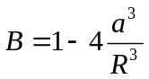 | θ _{corrected} = θ/B
20 | 0.04 | 19 | 0.9965705 | 19.0654
14 | 0.0196 | 40 | 0.99000145777 | 40.404
10 | 0.01 | 82 | 0.972564 | 84.313
9 | 0.0081 | 99 | 0.9623649 | 102.872
8 | 0.0064 | 123 | 0.946414 | 129.964
7 | 0.0049 | 161 | 0.92001 | 174.998
6 | 0.0036 | 187 | 0.872981 | 214.208
5 | 0.0025 | 242 | 0.780512 | 310.053

h)

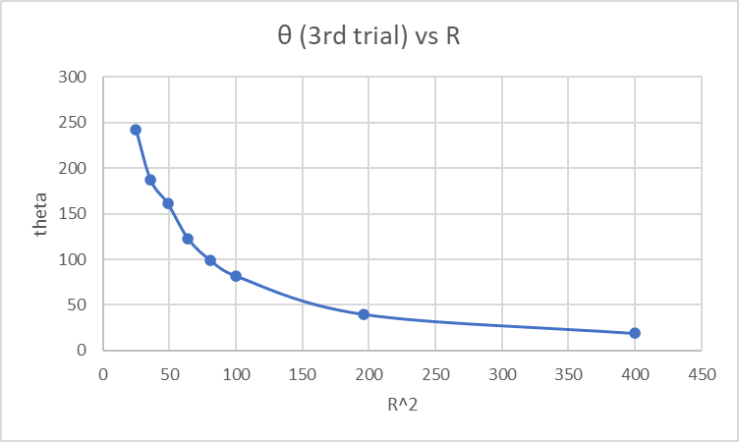

- As the radius between the 2 spheres increases, the torsional angle increases. They seem to be inverse square proportional.

4.1.1 Corrections to the Data

- Already filled out in the chart above

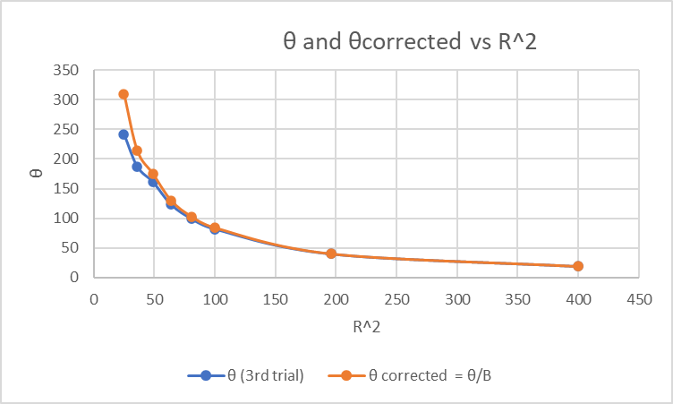

- They are still very similar. When R increases, the θ’s become virtually the same, but while they are close, the correction factor values are a little higher which indicates higher force than non correction.

Force versus Charge
- For a charging potential of 3 KV, The torsion angle at a position of 10 cm = 21.08 deg.
- This angle is about 4 times less, as when the charge, which is proportional to voltage, is halved twice, the force, which is directly proportional, also goes down by a factor of 4.

e) As voltage goes up, so does the charge, and since force and charge are directly proportional, then so is force and voltage.

The Coulomb Constant

4.3.1 Measuring the Torsion constant, Ktor

Table 3. Mass and Force Vs. Twist angle
Mass (mg) | Twist angle "θ" (degree) | Force (in Newton) = mass (in kg) x gravitational acceleration (9.8 m/s²) | K_{tor} = Force/θ
20 | 133 | 1.96*10⁻⁴ | 1.47368*10⁻⁶
40 | 262 | 3.92*10⁻⁴ | 1.496183*10⁻⁶
50 | 334 | 4.9*10⁻⁴ | 1.467*10⁻⁶

i)

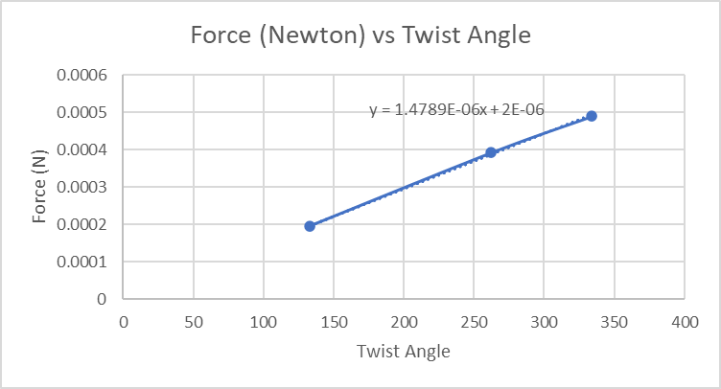

j) K_{tor} = the slope of the curve = 1.4789*10⁻⁶N/deg

4.3.3/4.3.4 Finding the Capacitance of the System & Measuring the Charges q₁ and q₂
g)
Table 4. The Charge on The Sphere
capacitance of the ice pail | 28.2pF
capacitance of the electrometer and the connecting leads | 118.2pF
C (total capacitance) | 146.4pF
V (Electrometer Voltage) | 43 VDC
q (Charge on sphere) = 2CV | 12.6076nC

4.3.5 Calculating Coulomb’s Constant (k) (This is a report work)

Table 5. Coulomb's constant
Distance "R" (cm) | θ _{corrected} | F = K_{tor} * θ_{corrected} | 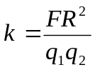
Distance "R" (cm) | (From table 2) | F = K_{tor} * θ_{corrected}
20 | 19.0654 | 0.000028196 | 7.1*10⁹
14 | 40.4 | 0.000059749 | 7.4*10⁹
10 | 84.313 | 0.000124694 | 7.85*10⁹
9 | 102.87 | 0.000152139 | 7.76*10⁹
8 | 129.96 | 0.000192204 | 7.74*10⁹
7 | 174.99 | 0.000258801 | 7.99*10⁹
6 | 214.2 | 0.000316791 | 7.18*10⁹
5 | 310.05 | 0.000458548 | 7.22*10⁹

k) average of the Coulombs Constant = 7.532 * 10^9 Nm^2/C^2
l) The actual value is 8.99 * 10^9 Nm^2/C^2 while the observed value was 7.532 * 10^9 Nm^2/C^2. This gives a percent error of:
percent error = ((theoretical – experimental)/theoretical) *100
= 16.22% error.

